C E C O S

U N I V E R S I T Y

*CECOS UNIVERSITY OF INFORMATION TECH. & EMERGING SCIENCE PESHAWAR.*

***PROJECT: AVL TREE BASE IMPLEMENTATION***

|  |  |
| --- | --- |
| ***Student Name*** | ***UMER FAROOQ KHAN***  ***MOUSA WAZIR***  ***ABDUL MUIZZ.*** |
| ***Student-ID No.*** | ***CU-4210-2023***  ***CU-2009-2021***  ***CU-4816-2023.*** |
| ***Semester*** | ***3rd*** |
| ***Discipline*** | ***Computer Science*** |
| ***Section*** | ***“C”*** |
| ***Subject*** | ***DATA STRUCTURE*** |
| ***Submitted To*** | ***MAM ARSHI*** |
| ***Submission Date*** | ***14.02.2025*** |

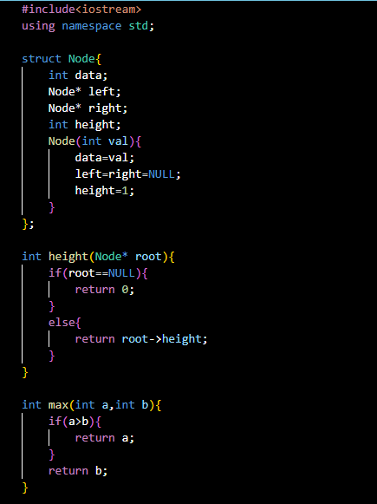

***ROTATION CASES:***

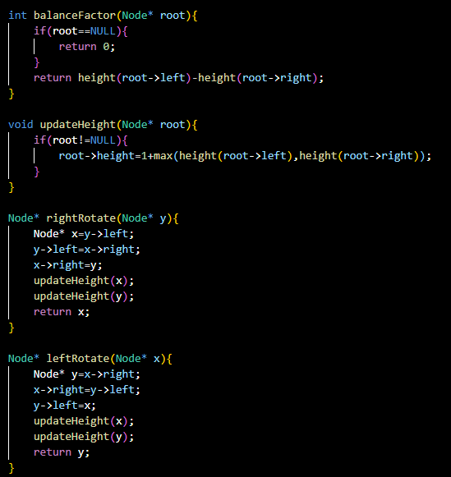

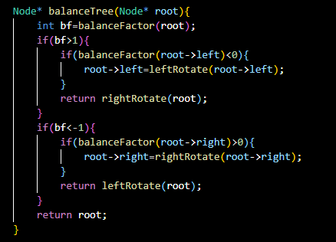

***INSERTION CASE:***

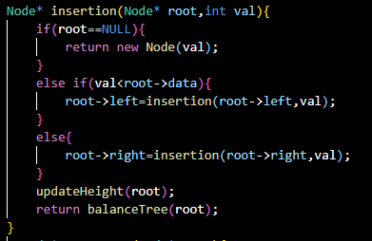

***DELETION CASE:***

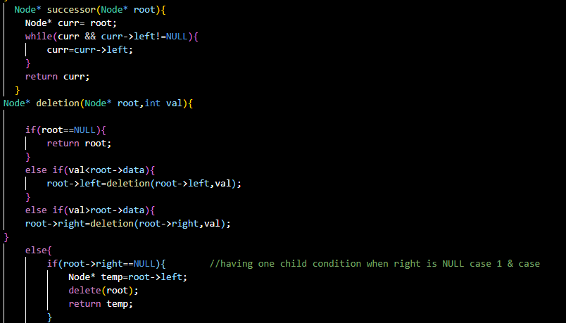

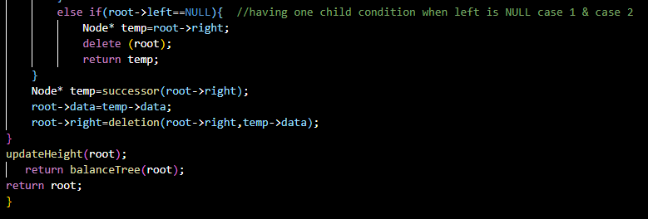

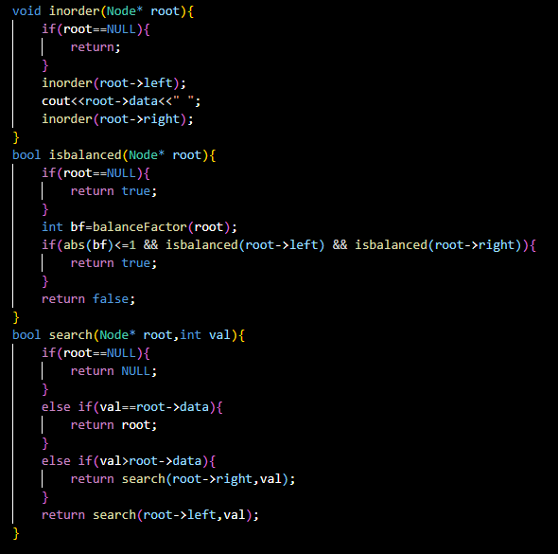

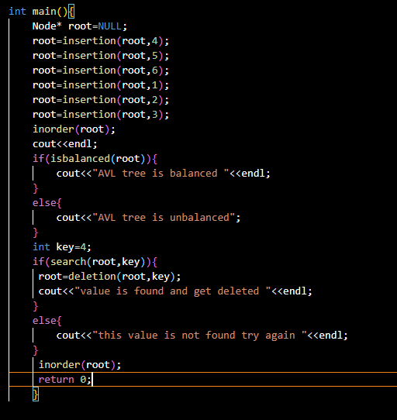

***Second case if not find value:***

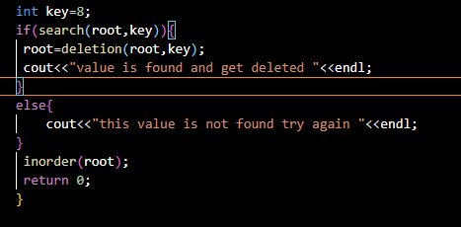

***OUTPUT:***

***For valuable value:***

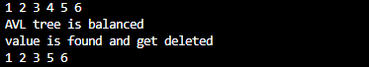

***For not valuable value:***

